LINUX BASIC COMMANDS
PART-3

1) which: return the path name

which ls
which bash
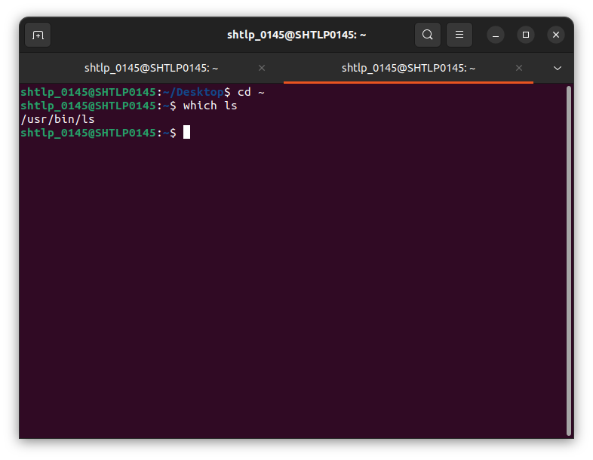
2)whatis:display short description of a command

whatis firefox
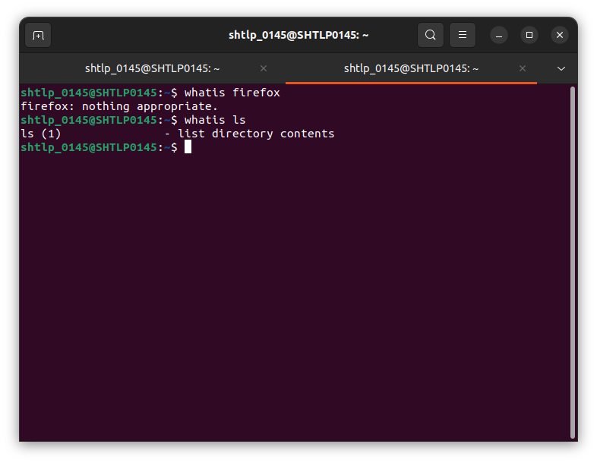
3)useradd: to add a user in linux

useradd name_of_user

useradd name_of_user -m:create home directory for this user

passwd user_name new_password: allow to change the password of user

4)groups: list all the groups that are current user connected to .

cat etc/groups: listing all the groups connected to operating system

sudo groupadd group_name:add this group in the operating system group list

sudo groupdel group_name:delete the group
sudo gpasswd -a user_name group_name: add user to the particular group
sudo gpasswd -d user_name group_name: remove user to the particular group

5).bashrc file: is a script which is executed whenever new terminal session is started in interactive mode.

6)df: reports amount of disk space used by file system
df -h: human readable of the output

7) du: used to estimate disk space used by files.

du downloads/

du -h: makes himan readable

du -s: gives summary
du -sh: gives summary which is human readable.

8)free: total amount of free and used space by the memory.

Free -h: human readable form

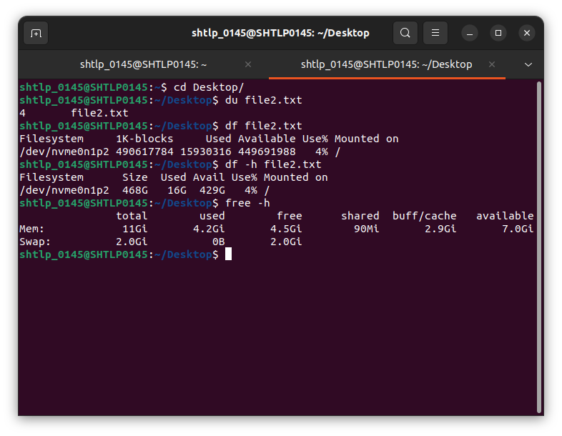

9)watch:runs scrips at regular interval
watch command_name: runs command at regular interval
watch -n time command_name : runs command at given time interval

10)head: first 10 lines of a file
head -n3 file: first 3 lines of file

11)tail: last 10 lines of a file

